Art 231 – Creative Crafts Curriculum
NYS Standards | Unit Name | Objectives | Instructional Resources | Vocabulary
 | Unit 1:
VA:Re7.1.HSIII a. Hypothesize ways in which art influences perception and understanding of human experiences. | What is Art?  - What are the different kinds of media found within the arts?  - What are some occupations related to the arts?  - What is the art of craft? | Students will identify a variety of occupations related to the arts.  Students will identify a variety of mediums used within the Visual Arts. | What is art - occupations, purpose, mediums1.docx | Functional Art  Craft – Wood, Clay, Glass, Textiles, Metal  Media
 | Unit 2:
VA:Cr1.2.HSI a. Consider a range of materials and methods of traditional and contemporary artistic practices to plan works of art and design.  VA:Cr2.1.Ia. Engage in making a work of art or design without having a preconceived plan.  VA:Cn10.1.Ia.  Document the process of developing ideas from early stages to fully elaborated ideas. | Mark Making & Altered Books  - Paper making  - Collage  - Paper decorating  - Marbling  - Book Binding | Students will make works of art that explore different kinds of subject matter, topics, themes, and metaphors.  Students will experiment with the use of visual arts materials, techniques, and processes. | Students will be introduced to a variety of historical and contemporary artists related to paper making and altered books.  Jane Kramer  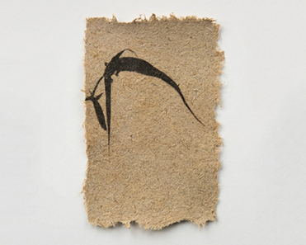  Josh Monroe  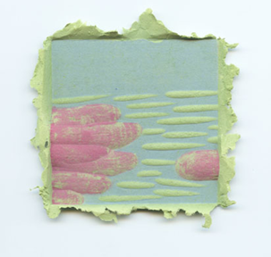  Angie Shen, Paper Pulp Paintings  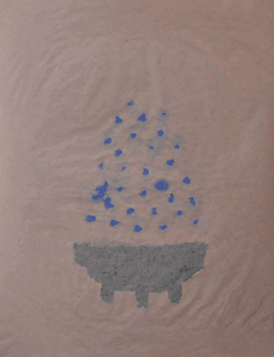 | Altered Book  Marbling  Binding  Overlap  Paper pulp  Screen  Paper Slurry
 | Unit 3:
VA:Pr4.1.8 a. Develop and apply criteria for evaluating a collection of artwork for presentation.  VA:Pr5.1.8 a. Collaboratively prepare and present selected theme-based artwork for display, and formulate exhibition narratives for the viewer.  VA:Re7.2.HSIII a. Evaluate effectiveness of images to influence ideas, feelings, and behaviors, of specific, audiences. | Paper Manipulation; Cutting & Folding  - Origami  - Layered paper shadow boxes  - Quilling | Students will experiment with the use of visual arts materials, techniques, and processes. | Students will be introduced to a variety of historical and contemporary artists related to paper manipulation.  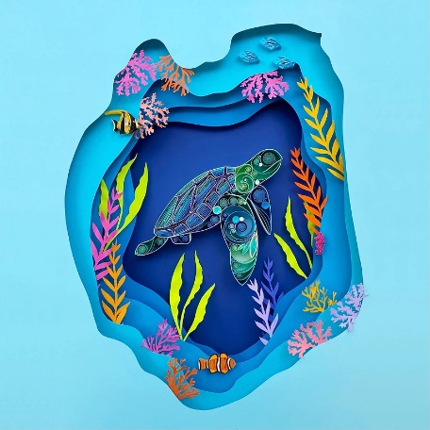Sena Runa  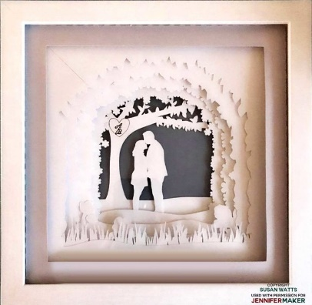 | Layers  Negative Space  Positive Space  Mount  Foreground  Middleground  Background
 | Unit 4:
VA:Re7.2.HSII a. Identify commonalities within a group of artists or visual images attributed to a particular type of art, timeframe, or culture.  VA:Cn11.2.HSII a. Explore past and current examples of artists working together with other professionals to generate solutions to ecological, social, and/or economic problems. | Weaving  - Paper weaving  - Radial weaving  - Basket weaving  - Tapestry on dowel  - Magazine paper rolling | Students will experiment with the use of visual arts materials, techniques, and processes. | Students will be introduced to a variety of historical and contemporary artists related to weaving.  Amber Kokenge  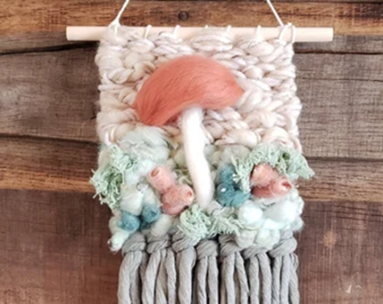Faid Ahmed  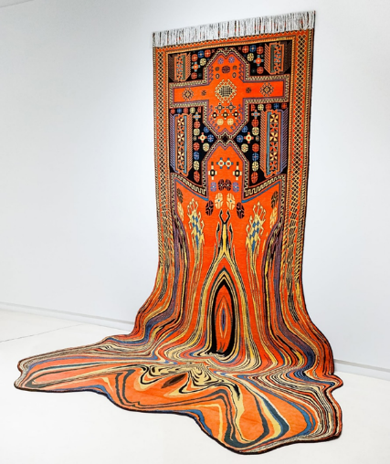  Lynne Francis-Lunn, Wonderous Waves  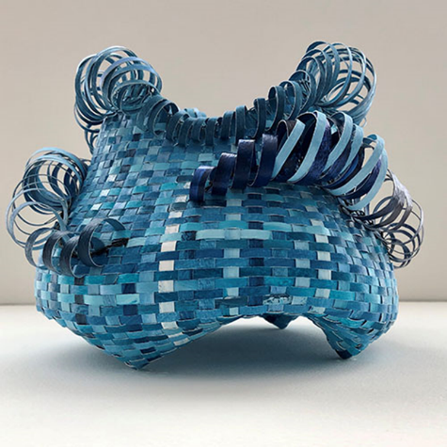 | Weaving  Loom  Warp  Weft
 | Unit 5:
VA:CR2.2.HSII a. Explain how traditional and non-traditional materials may affect human health and the environment and demonstrate safe handling and disposal of materials, tools, and equipment. b. Consistently apply ethical standards when making and distributing creative work. | Mosaic  - 2D paper mosaic – magazine pages, shades & colors  - Glass & Ceramic tile mosaics | Students will make works of art that explore different kinds of subject matter, topics, themes, and metaphors.  Students will experiment with the use of visual arts materials, techniques, and processes. | Students will be introduced to a variety of historical and contemporary artists and techniques related to mosaics.  Amy Rose Hahn, Erie PA  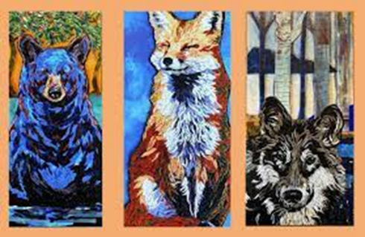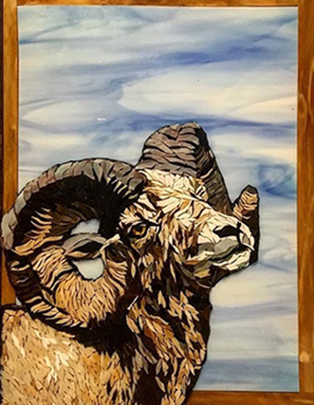 | Grout  Adhesive  Scoring  Wheeled Cutters  Nippers
 | Unit 6:
VA:Cr1.2.HSI a. Consider a range of materials and methods of traditional and contemporary artistic practices to plan works of art and design.  VA:Cn11.1.HSII a. Compare uses of art in a variety of societal, cultural, and historical contexts; and make connections to uses of art in contemporary and local contexts. | Fabric Dying  - Shibori - Japanese Art of Fabric Dying  - Batik (with wax resist)  - Eco dying  - Cyanotypes | Students will experiment with the use of visual arts materials, techniques, and processes. | Students will be introduced to a variety of historical and contemporary artists.  Firelei Baez: contemporary artist who uses batik in her large scale installations (below)  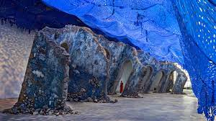  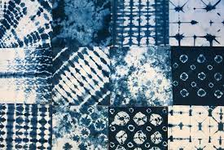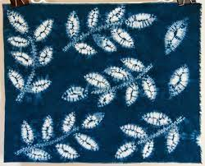  Marcia Baldwin, Equus Trio 2006  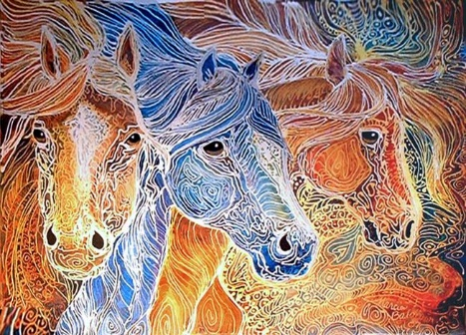Marcia Baldwin Batik Koi 01  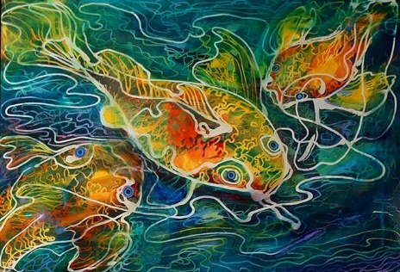Indonesian Batik  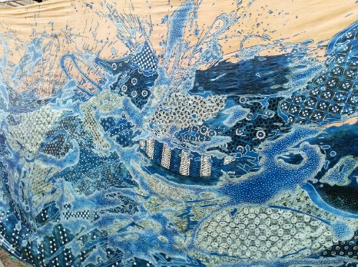 | Shibori  - Itajime  - Arashi  - Kumo  Indigo  Batik  Wax Resist  Cyanotype

NYS Standards | Unit Name | Objectives | Instructional Resources | Vocabulary
 | Unit 7:
VA:Cr2.1.HSIII a. Experiment, plan, and make multiple works of art and design that explore a personally meaningful theme, idea, or concept.  VA:Pr6.1.HSII a. Make, explain, and justify connections between artists or artwork and social, cultural, and political history. | Plaster Craft  - Masks (mold on face)  - Casting (hands, torso, etc) | Students will make works of art that explore different kinds of subject matter, topics, themes, and metaphors.  Students will experiment with the use of visual arts materials, techniques, and processes. | Students will be introduced to a variety of historical and contemporary artists related to plaster and casting.  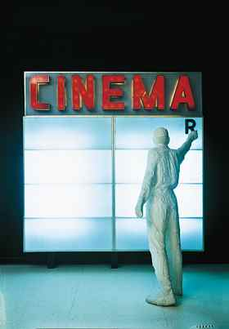  George Segal  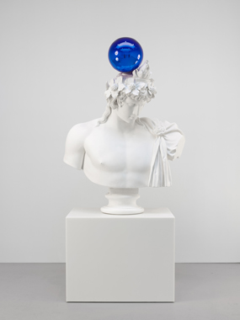  Jeff Koons | Plaster Craft  Mold  Casting
 | Unit 8:
VA:Cn10.1.HSI a. Document the process of developing ideas; from early stages to full elaboration. | Paper Mache | Students will make works of art that explore different kinds of subject matter, topics, themes, and metaphors.  Students will experiment with the use of visual arts materials, techniques, and processes. | Students will be introduced to a variety of historical and contemporary artists related to paper mache. | Paper Mache  Additive Sculpture  Paper pulp  Armature  Modeling
 | Unit 9:
VA:Cr2.2.HSI-Demonstrate an environmentally conscious approach to conservation, care, and clean-up of art materials, tools and the equipment in the classroom.  VA:Cn11.2.HSI-Investigate how skills used in developing artistic solutions can be applied to study in other disciplines and explore how they are sought-after work force attributes in other fields. | Clay  - Pinch pot  - Coil Pot  - Slab built Mug | Students will experiment with the use of visual arts materials, techniques, and processes.  Students will make works of art that explore different kinds of subject matter, topics, themes, and metaphors. | 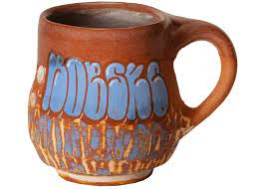  Roberto Lugo  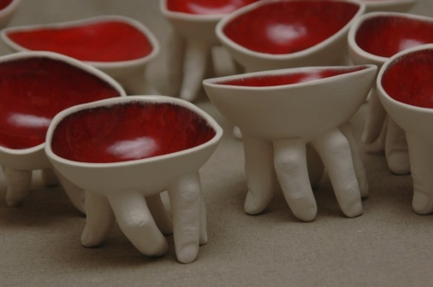  Ronit Baranga  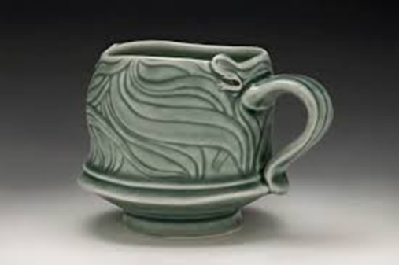  Elaine Coleman | Slip  Score  Coil  Slab  Sgraffito  Clay  Ceramic  Kiln  *Quartz Inversion*  -great science inclusion to discuss the chemical change that occurs in the kiln to change from organic clay to inorganic ceramic by the extreme temperature of the kiln.
 | Unit 10:
VA:Cr2.1.HSII a. Through experimentation, practice, and persistence, demonstrate acquisition of skills and knowledge in a chosen art form.  VA:Cn10.1.HSIII a. Synthesize knowledge of social, cultural, historical, and personal life with artmaking approaches to create meaningful works of art or design. | Weaving Extension - Coiled Baskets (Could be an extension of the basket unit,or mix it up from woven baskets) | Students will experiment with the use of visual arts materials, techniques, and processes. | Students will be introduced to a variety of historical and contemporary artists related to basket weaving.  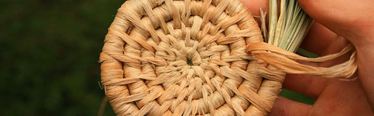Pamela Becker, Days End  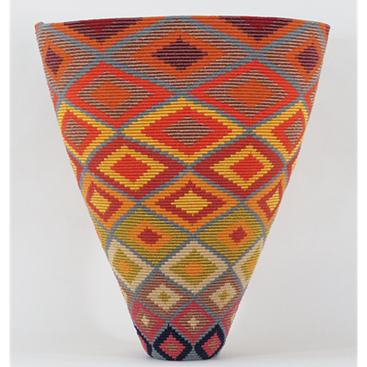
 | Unit 11:
VA:Cr2.1.HSII a. Through experimentation, practice, and persistence, demonstrate acquisition of skills and knowledge in a chosen art form.  VA:Pr4.1.HSIII a. Critique, justify, and present choices in the process of analyzing, selecting, curating, and presenting artwork for a specific exhibit or event. | Final Project: Students will create a work of art using one or more of the techniques they have learned throughout the course. | Students will make works of art that explore different kinds of subject matter, topics, themes, and metaphors.  Students will experiment with the use of visual arts materials, techniques, and processes. | Artist Statement - Written Reflection.pptx | Artist Statement  Critique

